

**UFCFFF-30-3**

**Software Development Project**

**Project Title: SwapMe Web Application**

**Date**: 9th May 2024

**Written By:**

Khoo Yi Qing (22052438)

Table of Contents

Chapter 1: Introduction 3

1.1 Problem Statement 3

1.2 Project Overview 3

1.3 Project Aims 3

Chapter 2: Method 4

2.1 Software Methodology 4

2.1.1 Rapid Application Development (RAD) 4

2.2 Project Management 6

2.2.1 Gantt Chart 6

2.2.2 Supervisor Meeting 6

2.3 Risk Management and Mitigation 7

2.4 Version Control Strategy 8

Chapter 3: Research 9

3.1 Case Studies 9

3.1.1 Vinted 9

3.1.2 TradeMade 10

3.2 Primary Research 11

3.2.1 Survey Introduction 11

3.2.2 Ethics Checklist 11

3.2.3 Survey Analysis 11

3.3 Technologies Selection (pugh matrix) 3;30 11

3.3.1 Database 11

3.3.2 Programming Languages 11

Chapter 4: Requirements (1000 words) 12

Chapter 5: Design (750 words) 12

Chapter 6: Results (1000 words) 12

Chapter 7: Conclusion and Next Step (500 words) 12

References 13

Appendix 14

Appendix A: Ethical Checklist 14

Appendix B: Survey Questions 17

Appendix C: Ethics Action Plan 22

# Glossary of Terms

RAD refers to Rapid Application Development.

HTML refers to

CSS

PHP

# Chapter 1: Introduction

## 1.1 Problem Statement

UWE Bristol Sustainability Hub provides an opportunity for the UWE staff and students to engage in face-to-face item-swapping events to swap and exchange their pre-loved items. The item-swapping events are typically conducted within a specified time, which is 10:00 a.m. to 3:30 p.m. every Tuesday to Thursday at a specified venue located in UWE Bristol, Block D, 1D015 (Sustainability Hub, n.d.).

Despite the efforts made by the sustainability hub, there is decreased interest of staff and students to physically attend the item-swapping event. In this digitalization era, the traditional face-to-face item-swapping event organized by the sustainability hub faces challenges to promote its sustainability goals.

## 1.2 Project Overview

To address the issues, an online item-swapping application, SwapMe is introduced as an alternative way to the traditional item-swapping event. SwapMe is a web application that is proposed to act as a user-friendly platform where users can browse and swap the item they no longer need for an item they desire via online communication. SwapMe application provides features and functionalities such as item listing, item searching, item sorting, item matching, item swapping, etc.

Additionally, the stakeholders of the project are the users of the web applications, specifically UWE staff and UWE students with a valid university email address so that they can log in and access the applications for item exchange.

## 1.3 Project Aims

The main purpose of the web application developed is to promote sustainability, waste reduction, and item reuse concepts. It is an alternative platform for the UWE staff and students to offer their pre-loved items a new home.

Furthermore, by providing an online item-swapping application alternative to traditional in-person item-swapping events, SwapMe aims to attract more UWE staff and students to participate in the item-swapping events as it overcomes the limitations of physical face-to-face item-swapping. The users can publish their unwanted items effortlessly and look for items that they desire without the need to be physically present at a specified venue just to browse for an item to swap.

# Chapter 2: Method

## 2.1 Software Methodology

### 2.1.1 Rapid Application Development (RAD)

RAD is chosen as the most appropriate software methodology to be utilized in the SwapMe Application. RAD focuses on fast and rapid delivery time and is well-suited for this software development project, aiming to develop a SwapMe Application that has to be delivered within a tight timeframe, which is around 3 months, through frequent iterations and actively incorporating user feedback (Chien, 2020). RAD introduces its significant elements that allow iterations and updates to the project to refine user requirements until the final deliverables meet the user’s satisfaction.

(Lucidchart Team, 2018) revealed that Rapid Application Development (RAD) consists of 4 phases:

1. Requirements Planning

The first phase is the requirement planning phase to gather broad requirements from the focus group, which are a few UWE students and UWE staff, to understand their expectations towards the application. During the requirement phase of this project, a survey is designed and distributed to UWE staff and UWE students to ascertain their needs to determine the goals and objectives for this project. (Further discussion regarding the survey will be discussed in the following Chapter 3). The main emphasis of this phase is to collect the requirements and specifications of the project, which is to allow UWE staff and students to publish and swap their pre-loved items.

Unlike the traditional waterfall model, RAD does not require the stakeholders to list out a very detailed requirement and specifications in the beginning, they are just required to articulate an overall expectation of the project. The overall specifications help us to separate specific requirements at different stages of the development cycle (kissflow, 2022).

1. User Design

In the user design stage, prototype iterations are created once the user’s requirement has been broadly scoped during the initial requirements planning phase. A prototype in software development is to stimulate how the actual web application works. It is an effective method to evaluate and validate our ideas with our stakeholders (Lonc, 2022).

Back to the project, as we already know the general purpose and objective of the SwapMe application is to act as a platform for UWE staff and students to publish and exchange their pre-loved items. Therefore, an initial prototype showcasing the user interfaces of the SwapMe application was deployed rapidly using an interface design tool, Figma. It was distributed to the focus group to review. Subsequently, the feedback is gathered, and the module is refined based on the users’ review. Adoption of the user reviews can provide us with a better insight into their preferences and areas for improvement. The process keeps iterating until the focus group is satisfied with the results and outcomes generated by the prototype.

1. Rapid Construction

Rapid Construction is a crucial stage for the actual development to take place. In this stage, the prototype design showcasing user interfaces is converted into functional web applications. Since most of the problems addressed are resolved during the iterative prototyping phase, we can save time while building and developing the actual SwapMe web application compared to the traditional waterfall model (Chien, 2020).

In this stage, the database is established to store the data, and the actual code of the web applications is written using Hypertext Markup Language (HTML), Cascading Style Sheets (CSS), Hypertext Preprocessor (PHP), and JavaScript. These technologies are utilized to construct, style, and ensure the functionalities of the website. All necessary testing, including integration testing and manual testing, was carried out to ensure the independent modules which contain different functionalities worked together seamlessly and functioned as expected, without any errors or mistakes. Stakeholders’ opinions are still important at this stage, if any specifications change or undiscovered problems arise, we revert to the previous prototype stage, otherwise, we proceed to the final cutover phase.

1. Cutover

Cutover is the final phase of RAD which is also the implementation stage. It aims to launch the actual web applications to the live server in the future. In this final stage, a thorough documentation and a poster are prepared to record the entire software development process of the SwapMe applications. The SwapMe web application is successfully developed at the moment and is ready to be proposed for adoption by the university. The university has the right to decide whether to upload it to the live server to benefit UWE students and staff in the future. Any issues or errors detected after the live launch of the SwapMe web application are still welcome to be raised and will be solved promptly along the way. Maintenance tasks will be carried out as well to ensure the ongoing smooth operation.

Overall, the utilization of rapid application development (RAD), which enables short requirement planning time and emphasis on highly iterative design and development, allows the SwapMe application to be delivered in a short time without compromising stakeholders’ satisfaction.

## 2.2 Project Management

Project management is incredibly important to ensure successful deliverables of the project. It is the practice of organizing, planning, and supervising the execution of the project from start to end (CodeAutomation, 2023). It involved an effective allocation of time and resources so that the project could be delivered within the budget and timeframe.

### 2.2.1 Gantt Chart

A Gantt Chart is an important project management tool to provides an overview of the project task list, project timeline, task dependencies, start date, end date, etc to ensure the project is delivered on time. The attached Gantt Chart below illustrates the project plan, enabling easy tracking of the project's progress.

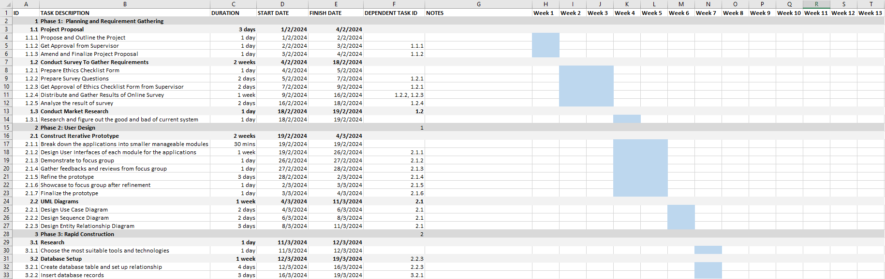

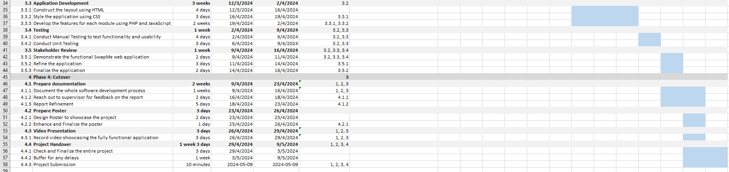

*The screenshot above shows evidence of effective project management*

*(The Gantt Chart above is included in the submission zip, named Project Plan.xlsx for a clearer view)*

### 2.2.2 Supervisor Meeting

Meetings scheduled with the project’s allocated supervisor, Mr. Prakash Chatterjee, take place in his office at UWE Bristol, Block Q, 2Q18, typically lasting for 30 minutes every meeting. Moreover, a weekly meeting with the program module leader, Dr. Steve Battle is also scheduled in UWE Bristol, Block Q, 2Q48 which lasts for 1 hour.

Both the supervisor and program leader check the project’s progress to ensure the students are on the right track and always provide necessary feedback and guidance whenever required. This is a golden opportunity to receive constructive reviews and feedback to further enhance the software development project and the proposed SwapMe web application.

## 2.3 Risk Management and Mitigation

Possible project risks are identified and a corresponding risk mitigation plan has been developed to address them.

|  |  |  |  |  |
| --- | --- | --- | --- | --- |
| **No.** | **Risks** | **Likelihood**  *(Unlikely, Low, Medium, High)* | **Severity**  *(Negligible, Minor, Moderate, Major)* | **Risk Mitigation** |
| 1. | Underestimate the development time | High | Major | 1. Separate and break down the applications into small and manageable modules with different features. 2. Estimate the execution time for each module carefully and allocate extra time for each execution as a buffer to prevent delays or any unforeseen issues. |
| 2. | Insufficient stakeholder responses to the survey | Medium | Moderate | 1. Distribute the survey through social media such as Facebook and Instagram via eye-catching graphics to catch user attention. 2. Reach out to the program leader to ask for their support to promote the survey. |
| 3. | Inadequate testing which leads to undiscovered errors | Medium | Major | 1. Conduct thorough testing plans to test the functionality, usability, performance, and security of the system. 2. Consider automated testing tools to increase test coverage. |
| 4. | Data loss or data corruption | Unlikely | Major | 1. Established backup at regular intervals. 2. Utilise version control tools to keep track of every modification. |
| 5. | User Data Privacy | Unlikely | Major | 1. Ensure the survey published strictly complies with the General Data Protection Regulations (GDPR). 2. Do not allow sensitive data to be stored or exposed to people who don’t need access to it. |

## 2.4 Version Control Strategy

Version control plays a pivotal role in a high-performance software development project. It empowers developers to keep track of every single change made to the source code (Soumya, 2019). It also serves as a backup to prevent any data loss or corruption. By containing the full history of the modifications made and automatically saving every version of the code, it guarantees seamless recovery of our work.

In this project, GitHub is utilized to record every modification made. GitHub is a cloud-based service for Git repositories (Richardson Ellis, 2022), which is also one of the most famous platforms used for version control. Leveraging GitHub, I commit each modification, to record and document every single change to the code while building the application over time. Screenshots are provided below as a piece of evidence to demonstrate the effective utilization of version control management for the SwapMe Application.

INSERT VERSION CONTROL EVIDENCE

# Chapter 3: Research

## 3.1 Case Studies

### 3.1.1 Vinted

Vinted is a well-known online digital platform enabling users to sell their pre-loved pieces, including accessories and clothes, without the physical needs of a shop to exchange items. It was established in 2008 and has accumulated a 105 million user base across 20 countries around the world. It aims to help users clear their closets by selling them online (Frost, 2024). Selling and purchasing a second-hand item can be done easily within a single Vinted application. The users have the freedom to list their items, sell them, and ship them, while at the same time, they can shop and purchase items listed by another seller (Vinted, 2023).

Vinted promotes eco-friendliness by facilitating the concepts of item-swapping that allows the buying and selling of second-hand items. It encourages the reusability of second-hand items, thereby reducing waste to the environment. It brings significant advantages to the community.

Inspired by the innovative concepts of the Vinted application, the SwapMe web application was created. Leveraging and utilizing the advantages of Vinted, SwapMe is tailored and customized for UWE staff and students to publish and browse second-hand items within the university ecosystem.

Diverging from Vinted’s concept, SwapMe restricts access strictly to UWE staff and students who have a valid university email address. Ensuring only UWE staff and students can log in and access the application, a secure environment is guaranteed for a university-centric item-swapping platform. Furthermore, SwapMe slightly differs from Vinted’s concepts. Vinted facilitates online transactions to purchase an item, whereas SwapMe prioritizes effective communication among users to swap an item instead of direct purchase.

### 3.1.2 TradeMade

TradeMade is an online trade and barter mobile application enabling users to trade goods and services. It desired to provide a safe and simple platform for the users to trade their unwanted items, with the option of trading other items or services in return (TradeMade, n.d.). Overall, the TradeMade mobile application aims to lower the carbon footprint and reduce landfill waste on the earth.

Similar to other item-swapping applications, it provides users the basic functionalities, including uploading an item or service and browsing listings for the items they desire. However, what makes this application unique is its functionality that allows users to propose a trade with other users, and negotiate deals by accepting or rejecting the trades offered, instead of direct purchasing of the item using online transactions. After the trades are accepted, users can chat to find a suitable time and location to meet up for an item exchange.

Sharing the same objectives as the TradeMade application, SwapMe is closely aligned with the functions and features offered by the TradeMade. Therefore, the TradeMade mobile application can serve as a valuable reference for the development of the SwapMe application. However, SwapMe slightly differs from TradeMade as it aims to facilitate item swapping within the university ecosystem only, rather than the public item swapping offered by TradeMade.

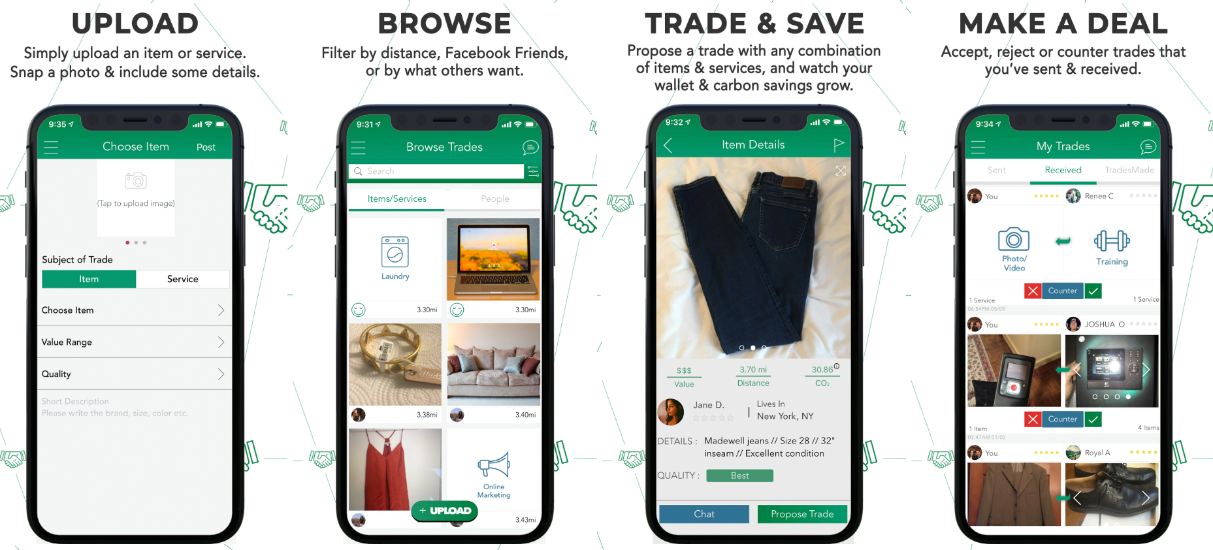

*(TradeMade, n.d.) provides an overview of a TradeView mobile application’s appearance, functionalities, and features.*

## 3.2 Primary Research

### 3.2.1 Survey Introduction

During the requirements planning stage, an online survey was conducted to gain insights into the interest of both UWE staff and students in the development of a second-hand item-swapping web application tailored specifically for the UWE community. The survey is conducted using Qualtrics, which is an online survey tool enabling us to create survey questions and collect feedback to increase stakeholders’ engagement (Zight, 2019). Survey questions are attached (Please refer to Appendix Section B: Survey Questions).

To gather sufficient responses, the survey was published and promoted using social media platforms including Instagram and Facebook. Furthermore, the survey was promoted with the assistance of the program leader in promoting the survey to students as announcements. Overall, a total of 55 responses were recorded, which exceeded the expectations.

### 3.2.2 Ethics Checklist

Before the survey is carried out, an ethics checklist form is necessary to be filled out and sent to the supervisor and program leader for review and sign-off. An approved ethics checklist form for this project is attached (Please refer to Appendix Section A: Ethics Checklist Form).

### 3.2.3 Survey Analysis

1. About You
2. Exploring second-hand goods
3. Expectations towards UWE SwapMe Application

## 3.3 Technologies Selection (pugh matrix)

### 3.3.1 Database

phpMyAdmin

### 3.3.2 Programming Languages

HTML

CSS

PHP

JavaScript

# Chapter 4: Requirements (1000 words)

* UML diagrams – Use Case Diagram(100)
* Derive (suitably numbered e.g. FR1, FR2,...) functional requirements (prioritised).
* Use Quality assurance (ISO/IEC 9126 Software Engineering: Product quality) to develop Non-Functional Requirements

e.g. numbered NFRs (e.g. NFR1, NFR2, ...) organised by quality:

1. Usability

2. Functionality

3. Reliability

4. Portability

5. Efficiency

6. Maintainability

# Chapter 5: Design (750 words)

* Software architecture (MVC)
* Relevant UML diagrams (e.g. database ERD diagram, Sequence)
* Wireframes for screen design
* Figma (Prototype).
* UX design map

# Chapter 6: Results (1000 words)

* Screenshots to demonstrate your use-case scenarios
* Automated or Manual Testing, Requirements Traceability Matrix

# Chapter 7: Conclusion and Next Step (500 words)

* Include critical reflection on the project content and process - e.g. Gibbs'

Admin Side

Mobile Version

# References

Chien, C. (2020) What is Rapid Application Development (RAD)? Codebots. 4 February 2020 [online]. Available from: <https://codebots.com/app-development/what-is-rapid-application-development-rad#:~:text=in%20business%20globally.->. [Accessed 29th April 2024]

CodeAutomation (2023) The Role of Project Management in the Software Development lifecycle Linkedin. 19 October 2023 [online]. Available from: <https://www.linkedin.com/pulse/role-project-management-software-development-lifecycle-xmrzf#:~:text=Project%20management%20is%20essential%20in,project%20from%20start%20to%20finish>. [Accessed 30th April 2024].

Frost, G. (2024) What is Vinted and how does it work? Times Money Mentor. 12 February 2024 [online]. Available from: <https://www.thetimes.co.uk/money-mentor/consumer-rights/what-is-vinted>. [Accessed 1st May 2024]

kissflow (2022) Rapid Application Development (RAD) | Definition, Steps & Full Guide kissflow.com. 31 October 2022 [online]. Available from: <https://kissflow.com/application-development/rad/rapid-application-development/>. [Accessed 30th April 2024]

Lonc, J. (2022) What is Prototyping in Software Development (and Why It’s Important) SPARK Business Works. 30 March 2022 [online]. Available from: <https://sparkbusinessworks.com/blog/prototyping-in-software-development/#:~:text=A%20prototype%20in%20software%20development>. [Accessed 30th April 2024]

Lucidchart Team (2018) 4 Phases of Rapid Application Development Methodology | Lucidchart Blog Lucidchart.com. 2018 [online]. Available from: <https://www.lucidchart.com/blog/rapid-application-development-methodology>. [Accessed 29th April 2024]

Richardson Ellis, D. (2022) Git vs GitHub: What’s the Difference? 1 November 2022 [online]. Available from: <https://blog.hubspot.com/website/git-vs-github> [Accessed 28th April 2024].

Soumya (2019) Version Control Systems GeeksforGeeks. 11 July 2019 [online]. Available from: <https://www.geeksforgeeks.org/version-control-systems/>. [Accessed 28th April 2024]

Sustainability Hub (no date) SUSTAINABILITY HUB UWE Students’ Union [online]. Available from: <https://www.thestudentsunion.co.uk/ents/event/12999/> [Accessed 1st May 2024]

TradeMade (no date) A Trade and Barter App, With a Good Cause’ TradeMade, Inc. 2020 [online]. Available from: <https://www.trademade-app.com/> [Accessed 2 May 2024]

Vinted (2023) How It Works Vinted. 2023 [online]. Available from: <https://www.vinted.co.uk/how_it_works>. [Accessed 1st May 2024]

Zight (2019) What is Qualtrics? A Quick Guide to Understanding the Ultimate Customer Experience Software Zight. 16 July 2019 [online]. Available from: <https://zight.com/blog/what-is-qualtrics/>. [Accessed 2nd May 2024]

‌

# Appendix

## Appendix A: Ethical Checklist



Faculty of Environment & Technology

Faculty Research Ethics Committee (FREC)

**Ethical Review Checklist for Undergraduate and Postgraduate Modules**

Staff and PG research students must not use this form, but should instead, if appropriate, submit a full application for ethical approval to the Faculty Research Ethics Committee (FREC).

*Please provide project details and complete the checklist below.*

**Project Details:**

|  |  |
| --- | --- |
| **Module name** | **Software Development Project** |
| **Module code** | **UFCFFF-30-3** |
| **Module leader** | **Steve Battle** |
| **Project Supervisor** | **Prakash Chatterjee** |
| **Proposed project title** | **UWE Item Swapping Application: SwapMe** |

**Applicant Details:**

|  |  |
| --- | --- |
| **Name of Student** | Khoo Yi Qing |
| **Student Number** | 22052438 |
| **Student’s email address** | [Yi3.Khoo@live.uwe.ac.uk](mailto:Yi3.Khoo@live.uwe.ac.uk) |

| **CHECKLIST QUESTIONS** | | **Yes/No** | **Explanation** |
| --- | --- | --- | --- |
|  | Does the proposed project involve **human tissue,** **human participants, animals, environmental damage, or the NHS.** | Yes | The proposed project will involve human participants to complete the survey via Qualtrics. |
|  | Will participants be clearly asked to give consent to take part in the research and informed about how data collected in the research will be used? | Yes | Before taking the survey, participants will be requested to give consent to participate in the study and will be informed about how the data collected in the research will be used. |
|  | If they choose, can a participant withdraw at any time (prior to a point of “no return” in the use of their data)? Are they told this? | Yes | Participants may withdraw at any moment before submitting the survey. |
|  | Are measures in place to provide confidentiality for participants and ensure secure management and disposal of data collected from them? | Yes | To ensure participant confidentiality, I will guarantee that the data collected from the participants is exclusively utilized for this research endeavor and promptly erased upon the project's completion. The collected data will be securely stored in UWE OneDrive, ensuring utmost protection and confidentiality. |
|  | Does the study involve people who are particularly vulnerable or unable to give informed consent (eg, children or people with learning difficulties)? | No | The research will only include students and staff from UWE Bristol and will exclude people who are particularly vulnerable or unable to provide informed consent. |
|  | Could your research cause stress, physical or psychological harm to humans or animals, or environmental damage? | No | The research only asks simple questions that will not cause participants stress, physical or psychological harm, or environmental damage. |
|  | Could any aspects of the research lead to unethical behaviour by participants or researchers (eg, invasion of privacy, deceit, coercion, fraud, abuse)? | No | Participants will not engage in any unethical behavior due to the research. The research will not involve any violation of privacy, deceit, coercion, fraud, or abuse. |
|  | Does the research involve the NHS or collection or storage of human tissue (includes anything containing human cells, such as saliva and urine)? | No | We will not collect any human cells from participants in the research. |

Your explanations should indicate briefly for Qs 2-4 how these requirements will be met, and for Qs 5-8 what the pertinent concerns are.

* **Minimal Risk:** If **Q 1 is answered ‘No’**, then no ethics approval is needed.
* **Low Risk:** If **Qs 2-4 are answered ‘Yes’ and** **Qs 5-8 are answered ‘No’**, then no approval is needed from the *Faculty Research Ethics Committee* (FREC). However, your supervisor must approve (a) your information and consent forms (Qs 2 & 3) and (b) your measures for participant confidentiality and secure data management (Q4).
* **High Risk:** If **any of Qs 5-8 are answered ‘Yes’**, then you must submit an application for full ethics approval *before* the project can start.This can take up to 6 weeks. Consult your supervisor about how to apply for full ethics approval.

**Risk Assessment:** Separate guidance on risk assessment can be found on UWE’s Health and Safety forms webpage at <https://go.uwe.ac.uk/RiskAssessment>. If needed, you must complete a Risk Assessment form. This must also be attached to your application for full ethics approval if your project is **High Risk**.

|  |
| --- |
| **Your supervisor must check your responses above before you submit this form.** |
| **Submit this completed form via the *Assignments* area in Blackboard (or elsewhere if so directed by the module leader or your supervisor)***.* |
| After you have uploaded this form, your supervisor will confirm it has been correctly completed by “marking” it as *Passed*/100% via the *My Grades* link on the Blackboard*.* |

Further research ethics guidance is available at <http://www1.uwe.ac.uk/research/researchethics>

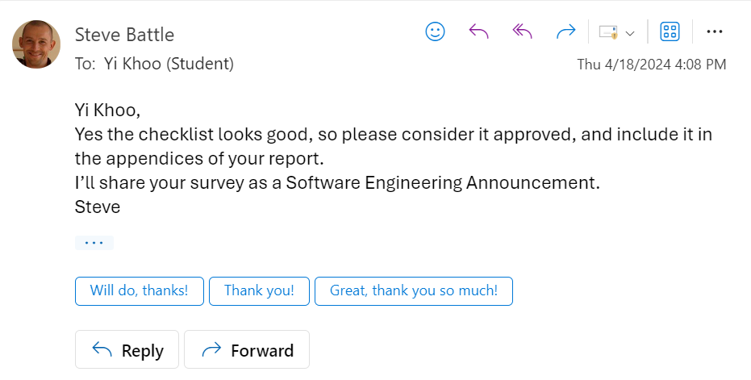

*Evidence of ethical checklist approved*

## 

## Appendix B: Survey Questions

UWE SwapMe Application Survey

Start of Block: Informed Consent

Q1.   
Welcome to the research study! The survey aims to gauge the interest of both staff and students in the development of a second-hand website tailored specifically for the university community. Your responses will be confidential.

The study should last approximately 2 minutes. Your participation is highly appreciated, and it is entirely voluntary. You can withdraw at any time by contacting Khoo Yi Qing via email: Yi3.Khoo@live.uwe.ac.uk.

By clicking the button below, you acknowledge that your participation in the study is voluntary. You are 18 years of age. You are aware that you may choose to terminate your participation at any time for any reason.

* I consent, begin the study
* I do not consent, I do not wish to participate

Skip To: End of Survey If = I do not consent, I do not wish to participate

Q2. Which is your age group?

* Under 18
* 18 - 24
* 25 - 34
* 35 - 44
* 45 - 54
* Over 55

Q3. What group do you fall under?

* Student
* Staff

Q4. Have you ever used second-hand websites to buy or sell items in the past? (eBay, Vinted, etc.)

* Yes
* Maybe
* No **\*\*\*If you don’t use any second-hand website, then you can ignore the remaining questions and have finished the survey. Thank you!**

Skip To: End of Survey, If Have you ever used second-hand websites to buy or sell items in the past? (eBay, Vinted, etc.) = No

Q5. How frequently do you engage in buying/selling through second-hand websites?

* Weekly
* Monthly
* Quarterly
* Semiannually
* Anually

Q6. Are you aware of any existing second-hand swapping websites or platforms? If so, which ones have you used?

* eBay
* Vinted
* Facebook Marketplace
* Amazon Marketplace
* Others (Please Specify) _________________________________________________

Q7. Have you encountered any challenges or limitations when using these existing second-hand swapping platforms?

* Yes (Please Specify) __________________________________________________
* No

Q8. Please rank the following concerns you may have while using a second-hand swapping website

1. Reliability
2. Security
3. User Experience
4. User Interface (UI)

Q9. Would you be more inclined to participate in item swapping if it were facilitated through an online item swapping website, compared to physically attending swapping events at the University of the West England (UWE)? Why?

* Yes (Please Specify) ________________________________________________
* Maybe (Please Specify) ________________________________________________
* No (Please Specify) ________________________________________________

Q10. Would you be interested in a dedicated second-hand swapping website (swapMe) specifically tailored for UWE students?

* Extremely unlikely
* Somewhat unlikely
* Neither likely nor unlikely
* Somewhat likely
* Extremely likely

## Appendix C: Ethics Action Plan

|  |  |  |  |
| --- | --- | --- | --- |
| **Data Ethics Canvas**  **Data Ethics Issue**  **Ethical Concerns** | **Choose THREE concerns from this left-hand list and provide a brief REASON for your choice.** | **Why do you think this is so important? State briefly WHY you think it could be an issue.** | **What actions would you suggest needs to be taken for your project or dissertation topic to lessen the impact of this ethical concern?** |
| **Legal Issues** | Prevent users from publishing prohibited items for swapping. | The application should not be misused for any harmful or illegal activities which carry negative impacts. | -Articulate terms and conditions of item swapping.  -Automatically detect prohibited items using algorithms and remove the specific item from the listing once identified as a banned item. |
| **Data Ethics & Data Protection** | Think about what happens if the platform secretly shares user’s data with other third-party marketing companies without any consent? | Users might receive annoying advertisements or even face criminal harassment if they do not know where their data goes. | -Ensure the platform follows the GDPR data protection framework.  -Only collect necessary data from students.  -Give students the right to customize their privacy settings. |
| **Equality and Diversity** | Ensure equal access to the application regardless of background, race, culture, beliefs, abilities, etc | The application should treat students with disabilities with the same respect as normal students. | -Implement text-to-speech function to help students with visual problems.  -Provide font colour switching feature to help students who are colour blind.  -Provide multilingual support for students with language barriers. |